COMMUNICATION

Comparing Partisan Bias in the 2020 Presidential Election
With Partisan Bias in the Five Other Presidential Elections in the 21st Century *

Jonathan Cervas
Carnegie Mellon University

Bernard Grofman
University of California, Irvine

John F. Nagle
Carnegie Mellon University

July 28, 2021

* Cervas is a Post-Doctoral Fellow, Institute for Strategy and Politics, Carnegie Mellon University (CMU). Grofman is Distinguished Professor of Political Science and Jack W. Peltason Chair of Democracy Studies, the University of California, Irvine. Nagle is Professor Emeritus of Physics at CMU. Grofman’s research was supported by the Peltason Chair. We are indebted to J. L. Lederman, an undergraduate at CMU for helpful work under the supervision of Professor Cervas on the topic of this paper.

ABSTRACT

We examine partisan bias in the 2020 presidential election and compare it to partisan bias in the five other presidential elections in the 21st century. We present the data in visual form using a newly developed graphical tool, a folded seats-votes curve. We show how 2020 and 2016 are extreme outliers with respect to the absolute magnitude level of partisan bias in the Electoral College each election displays. In 2016, 2020 and 2000 bias runs in a pro-Republican direction; in the other three elections in this century, the opposite is true. JONATHAN IS THIS CORRECT? We also show how the magnitude of our assessment of partisan bias can vary with where on the seats-vote curve we look to find bias; in particular, whether we look at a 50% vote share, or at the vote share actually observed in the election. In particular, we find the (two-party) vote share for the Democratic candidate that would yield no partisan bias in each of these six elections. JONATHAN PLEASE PROVIDE AS PART OF A TABLE IN THIS PAPER. However, we also show that the direction of increase in bias with increasing vote share for a given party need not be monotonic.

The goals of this essay are two-fold.

First, using a simple way to visualize seats-votes curves in the context of two-party politics, the folded seats-votes curve (Cervas, Grofman and Nagle, 2021) we show the level of partisan bias (Tufte, 1973; Grofman, 1983; Gelman and King, 1994; Grofman and King, 2007) for each of the six presidential elections in the 21st Century at a 50% vote share and at the actual vote share that was received by the Democratic candidate in the election. We also show the Democratic vote share needed to give a situation of zero partisan bias, and we show that partisan bias varies at different points on the seats-votes curve, and that change in partisan bias need not be monotonic with change in Democratic vote share.

Second, we compare the results in 2020 with those in earlier years to demonstrate that 2016 and 2020 were clear outliers in the extremity of the absolute magnitude of their partisan bias. We also show that partisan bias in the Electoral College operated in a pro-Republican direction only in 2000, 2016 and 2020. JONATHAN IS THIS CORRECT?

Like the usual seats-votes curve for a two-party contest, in a folded seats-votes curve, seat share is shown on the y axis and vote share on the x axis. However, for folded seats-votes curves, unlike the standard seats-votes curve which has values being shown for only one of the two parties (running from 0-100%, or for an included range such as 35% to 65%), a folded seats-votes curve, such as those shown in Figure 1, simultaneously shows values for each of the two parties over the range 50%-100%. In other words, we have arranged these plots so that both the Republican seats-votes curve and the Democratic seats-votes curve lay on the same axis. The reason we refer to this way of representing seats-votes relationship as a folded curve is because it takes the usual seats-vote cure and folds it on itself as if it were hinged at the 50% vote share.

Figure 1 {#sv_plots} shows folded seats-votes curves generated stochastically for the set of six presidential elections held in the 21st century. As readers are well aware, two of these elections (2000 and 2016) were inversions, and the other four were not. For any given vote share the gap between the values at that vote share for the two parties shows the asymmetry in the seats-votes distribution and may be used as a measure of partisan bias (and its directionality) at that point. Note most importantly that partisan bias need not be bias in favor of the winner of the election. A sufficiently strong vote performance can overcome an Electoral College bias against one’s party.

<< Figure 1 about here>>
JONATHAN WHEN YOU REDO THESE figures CAN YOU SHOW A LIGHT DOTTED VERTICAL LINE THROUGH THE 50% VOTE SHARE AND continue to show A LIGHT DOTTED horizontal LINE THROUGH THE 50% SEAT SHARE SO THAT IT IS EASY TO SEE WHERE BIAS AT 50% IS for both votes and seats.

SECOND CAN YOU SHOW THE ACTUAL SEATS VOTES POINT IN THE GRAPH AND PROVIDE THAT VALUE IN A TEXT BOX. And can you show a light dotted horizontal line to show bias at the actual vote share.

THIRD,I WOULD GET RID OF THE GRAY SHADING; THE FACT IT IS TWO SHADES OF GRAY WITH SOME OVERLAP IS JUST CONFUSING. IF YOU LIKE YOU CAN STILL SHOW THE 95% OR 99% CONFIDENCE BOUNDS ON THE TWO CURVES.

Figure 1 {#sv_plots}. Two-Party Folded Seats-Votes Curve:
2000, 2004, 2008, 2012, 2016, 2020
(shown for the range of likely feasible values: 50% to 64%)

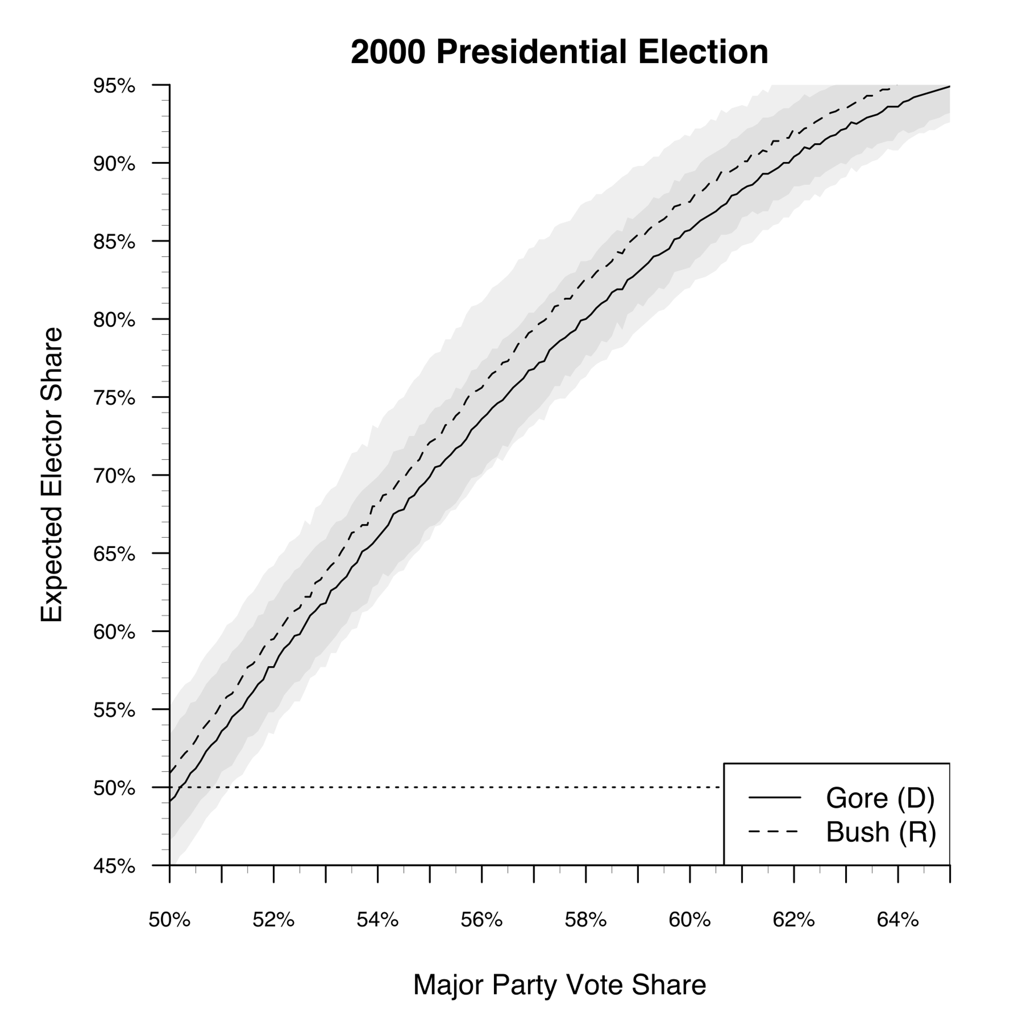

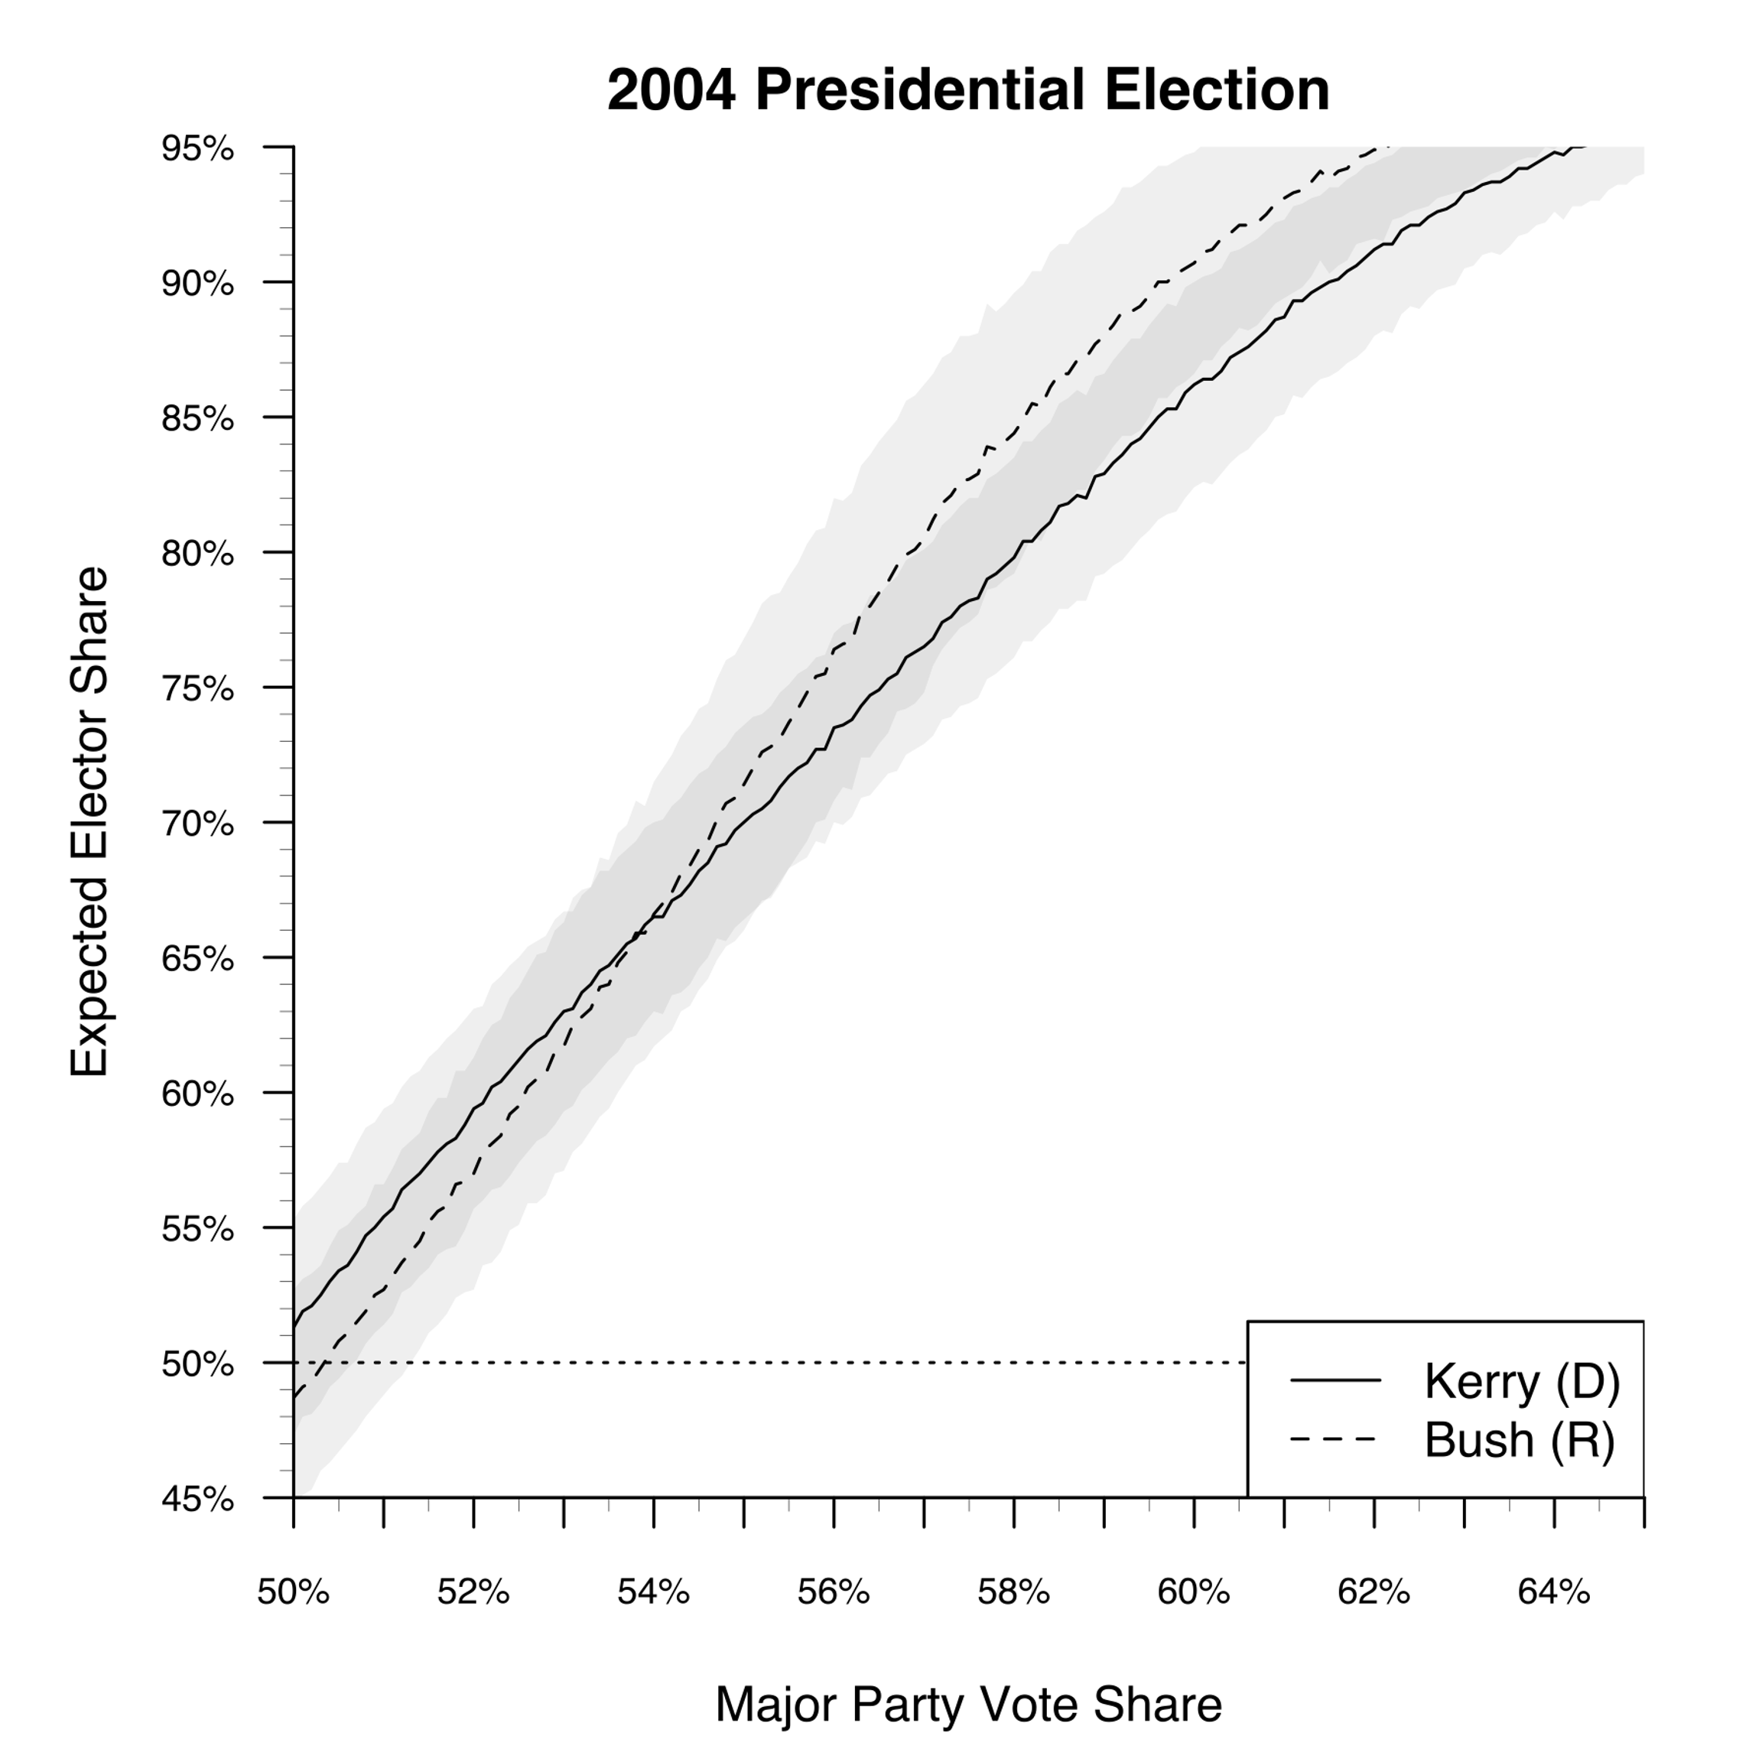

JONATHAN, 2008 CURVE NEEDED

JONATHAN, 2012 CURVE NEEDED

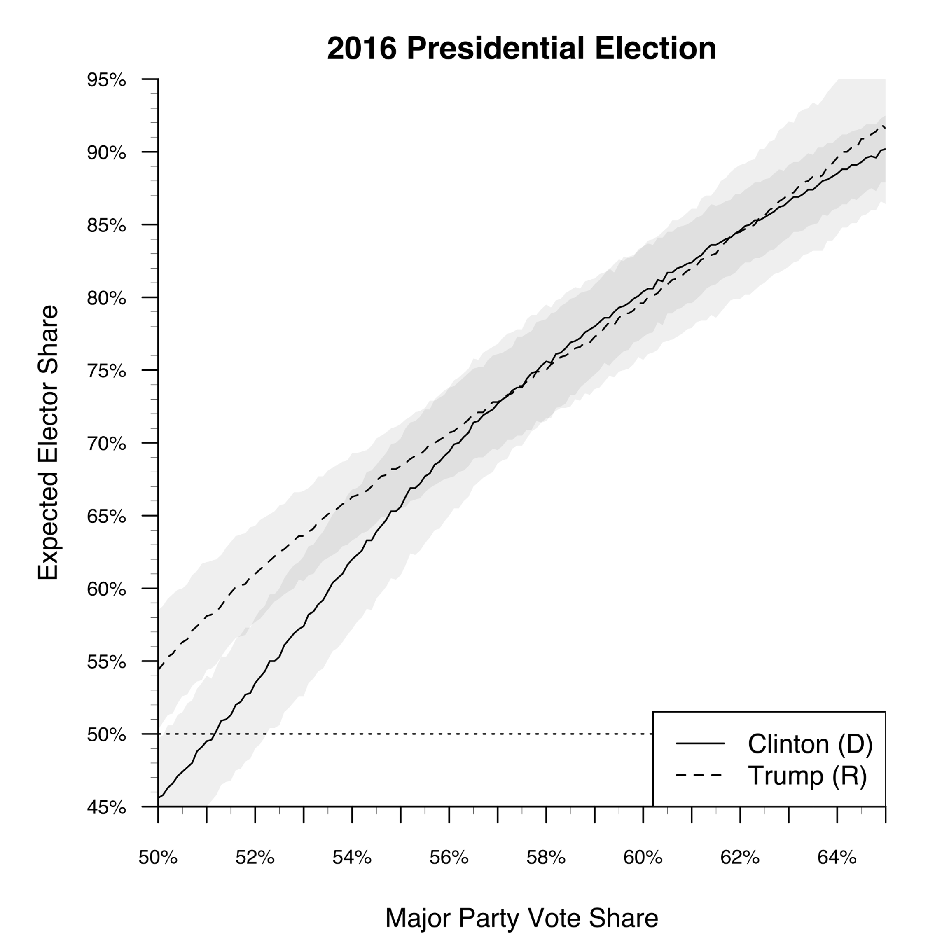

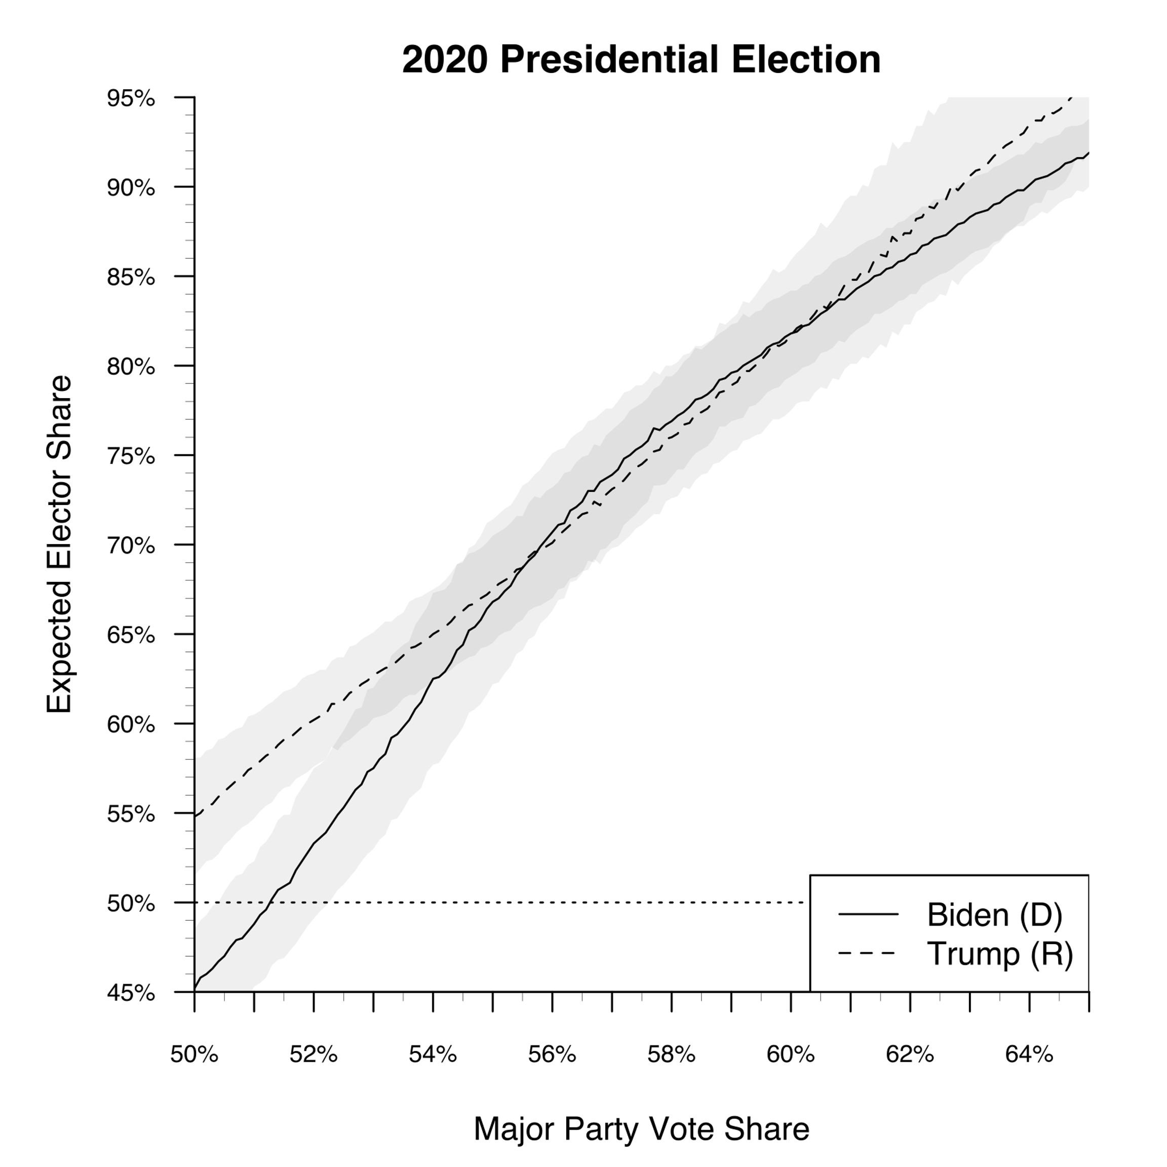
Folded seats-votes curves are particular useful in visualizing how seats-votes relationship vary over the vote range. We can read out from the plots shown in Figure 1 most of the features of interest. In particular, the figures allow to read out the partisan bias value at a 50% vote share and the partisan bias value at the actual vote share that was received by the Democratic candidate in the election, and they also allow us to quickly find the Democratic vote share needed to give a situation of zero partisan bias. The measure of partisan bias at a k% vote (seat) share is simply the seat difference between the two parties at that vote (seat) share. The sign tells us which party is being favored. And, because the folded seats-votes curve we report are generated by a process with stochastic error, we can calculate confidence bounds around our various partisan bias estimates. We show 95% JONATHAN, please FILL IN AND PROVIDE confidence bounds in the figures.

What we also can see from Figure 1 is that, even though there is a considerable resemblance between the seats-votes pattern in immediately adjacent presidential elections, the resemblance is far from perfect. In particular, the absolute magnitude of the partisan bias levels in 2016 and 2020 are extraordinarily high as compared to the other four elections in the 21st century, as shown by the large gap between the Republican and Democratic curves both at the 50% vote share and at the observed vote share in the actual election. Moreover, while in 2016 and 2020 bias tend to diminish as Democratic vote share increases, it takes a quite high Democratic vote share, 56% in 2016 and 57% in 2020, before we get to a level of zero pro-Republican bias. Furthermore, in 2016 once we go past a Democratic vote share of 56%, there is essentially no bias (perhaps a slight tilt to the Democrats) but then, once we get to vote share values near to 64%, bias again is a pro-Republican direction, but low; while in 2020, once we go past a vote share of 57%, there is again virtually no bias (perhaps a slight tilt to the Democrats) until we get to vote share of 60% or so. But at 60% we again begin to see non-trivial pro-Republican bias emerging.

The pattern in 2000 is quite different, though still exhibiting pro-Republican bias at 50% and at the actual Democratic vote share. In 2000, we see a virtually constant, but low, level of partisan bias across the entire Democratic vote share range from 50% to 64% so, no matter how high the Democratic two-party vote share, bias remains in a pro-Republican direction.

The pattern in the other three 21st century elections are ones with pro-Democratic bias at 50% and at the actual Democratic two-party vote share, JONATHAN, IS THIS CORRECT? but at far lower level of bias then is found in the pro-Republican direction in 2016 and 2020. In 2004, the pro-Democratic bias for low values of Democratic vote share reverses to become pro-Republican bias for Democratic vote shares above 54%. In 2008, JONATHAN FILL IN. In 2012, JONATHAN FILL IN.

Table 1 summarizes some of the key pieces of information reported above.

<< Table 1 about here>> JONATHAN TO create-- showing for each year the Signed bias at 50%, the signed bias at the actual vote share, and the value at which the curve first exhibits zero bias.

REFERENCES

JONATHAN PLEASE FILL IN

Cervas, Jonathan, Bernard Grofman, and John F. Nagle . 2021. A Simple Graphical Tool to Display seats-votes relationships. Unpublished manuscript, Carnegie-Mellon University.

Gelman and King, 1994 TBA

Grofman, 1983 TBA

Grofman and King, 2007 TBA

Nagle and XX 2020 TBA

Tufte, 1973 TBA

The folded seats-votes curve was inspired by the measure of global symmetry in Nagle and XXX (2020). That measure looks at total area between the two curves shown in each of the subfigures in Figure 1. Thus, in effect, it calculates global symmetry as if all vote share values were equally likely. More recent work allows for a non-uniform distribution over those seat share values based on stochastic expectations derived from the past history of election popular vote outcomes and inter-election shifts (Cervas, Grofman and Nagle, 2021). JONATHAN PLEASE THINK ABOUT WORDING
Following Gelman and King (1994), our simulation assumes uniform swing with stochastic error. We used a standard error of JONATHAN FILL IN, intended to approximate data on inter-election shifts between presidential elections. We ran JONATHAN FILL IN simulations to arrive at our smoothed curves.
Also, in looking at a folded seats votes curve we are effectively subtracting away the effects of responsiveness (if we assume it to be the same for both parties for any given vote share) and are left with a pure measure of bias. JONATHAN THINK ABOUT! IS THIS CORRECT??!
By, assuming a uniform distribution of vote over some given range of vote share values, we could also find the mean partisan bias over that range as the area between the Democratic and Republican curves.
When we go from one election to the next not only are there movements from less than voting age status to voting age status, in-migrations and out-migrations to any given state, as well as deaths and incapacitation that affect who is in the electorate, but the nature of the campaign (and the candidates) may lead to differences in the relative attractiveness of the Democratic and Republican candidates to various segments of the electorate—and this segmentation may be geographically linked in a fashion that alone is sufficient to generate differences in the state-specific distribution of two-party vote share from one election to the next even if aggregate level two-party vote shares do not change much or even at all. Indeed, the presidential elections in the 21st century are all remarkably similar to one another in terms of Democratic candidate share of the popular vote, since all are among the most competitive in our nation’s history. We would need to go back to the elections between 1876 and 1888 to find comparable competitiveness levels. JONATHAN, PLEASE THINK ABOUT WORDING
The question of which of the 21st century elections the election of 2024 is most likely to resemble is beyond the scope of this short comment, but it is a question which the authors are currently investigating.

